How To Migrate
Dev To Prod
In Android

Document Control
Creation Date:
Last Update:
Version: 1.0
Author: Justin Zirkle
Last Modified By:
File Name: New MXP tables - Requirements.doc
Location: \\nclmiami\shares\OnboardRevFinance\ben\mxp\Requirements

TeloCure Migration

VISION
To Bring Innovation For All

TeloCure Internal Use Only
Copyright @ 2020 TeloCure
This copyright notice does not imply publication of this document.

Document Overview

REVISION HISTORY
Version | Date | Description | Editor
1.0 |  | Initial Document Created
1.1

Open ODI

Open Remote Desktop Connection

Connect to xxxxx | 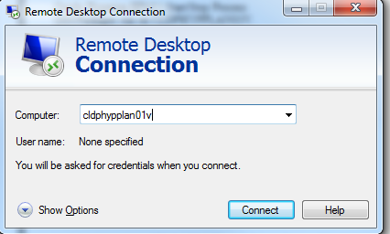
Connect as as shown in the box | 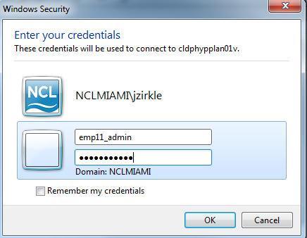
Double Click on the ODI Studio Icon. | 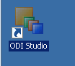
The following window will open. Click “Connect To Repository…” | 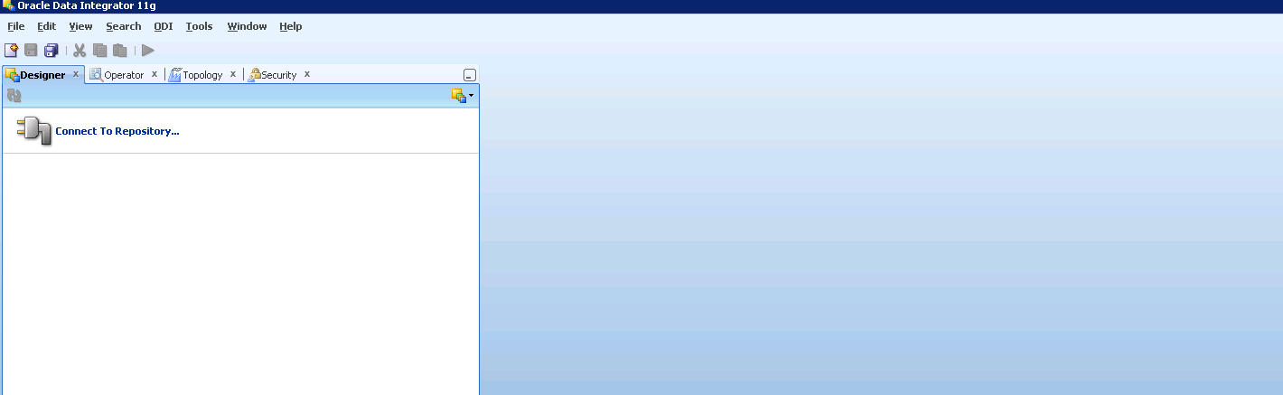
Click “Ok” | 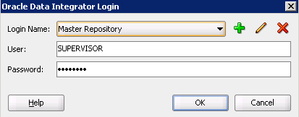
The window will update and appear as below | 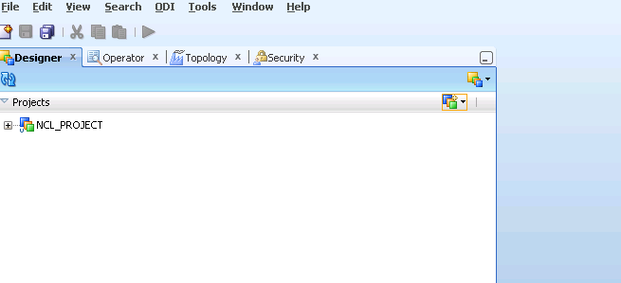

Run an ODI Package.
Navigate to the folder location - NCL PROJECT / Ncl / Environment / Packages | 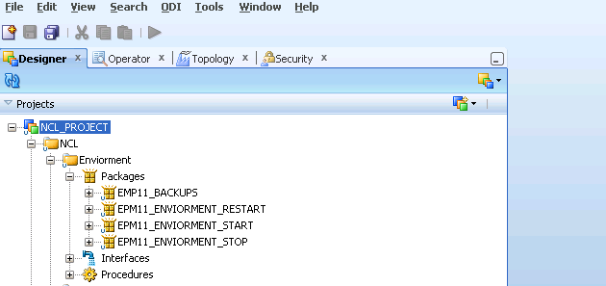
Select the package you want to run. To start the environment, select the package EPM11_ENVIORMENT_START

To stop the environment select, the package EPM11_ENVIORMENT_STOP

To execute a package right click on the package and select Execute as shown below: | 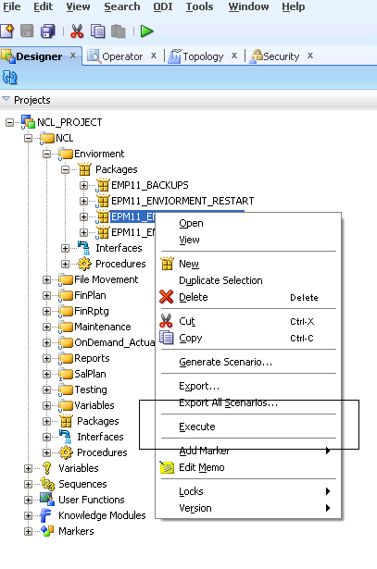
Click “Ok” | 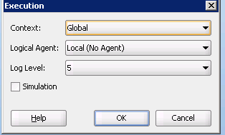
The following Window will appear. Click OK | 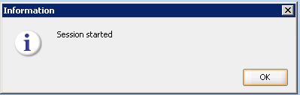

Check status of ODI Package
To see if the package is running/completed click on the Operator tab and then expand the date to see the packages running & their status.  Note: The green lightning bolt is a currently running package. | 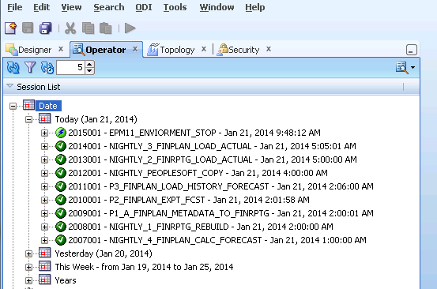
Once the package has completed, a green check mark will appear next to the package.  An email will also be sent to the support distribution list  Once this step is completed, validation of the master logs should be done to confirm if it started/stopped as expected. | 